**Lithics-England, Wiltshire, Swallow Head, Kennet Spring Farm-Scrapers, Gravers, Burins-5500 BCE**

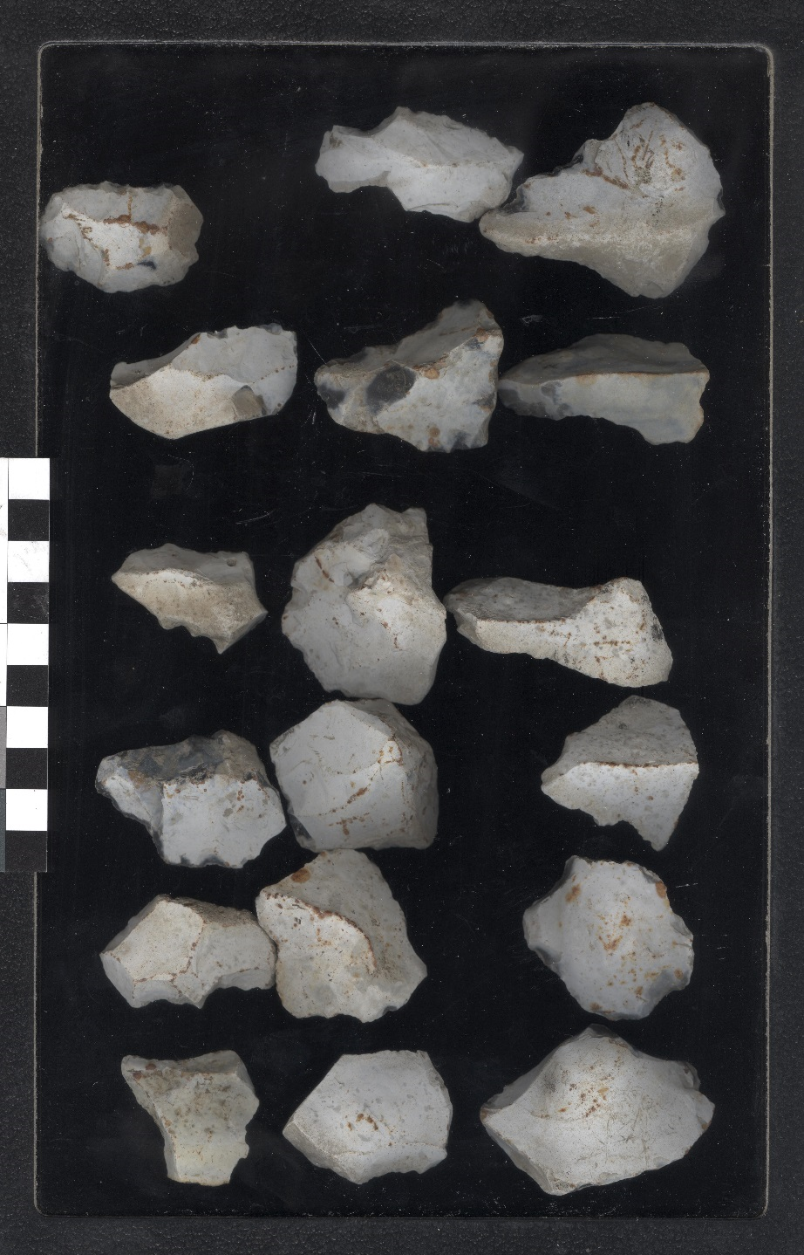

**Fig. 1.** England, Cambridgeshire, Swallow Head, [Kennet] Spring Farm, Neolithic Flint Tools-5500 BCE.

**Case No.: Lithics**

**Formal Label:** England, Cambridgeshire, Swallow Head, [Kennet] Spring Farm, Neolithic Flint Tools-5500 BCE

**Display Description:** This collection of Neolithic tools from Kennit [i.e., Kennet] Spring = Swallowhead Spring is interesting because it comes from a Late Neolithic area near Silsbury Hill, Wiltshire, the largest prehistoric man-made mound in Europe dating to 2490 BCE-2340 BCE. The construction of this mound was an intricate pyramidal polygon which took several man-years to complete.

**Accession Number:**

**LC Classification:** GN776.22.G7

**Date or Time Horizon:** Late Neolithic, 2490 BCE-2340 BCE

**Geographical Area:** Swallowhead, [Kennet] Spring Farm is .5 mi from Silsbury Hill, and just north of the South Long Barrow.Wiltshire and .5 km south of Silsbury Hill.

**Map, GPS coordinates:** Latitude: 51.411833N  Longitude: 1.856167W

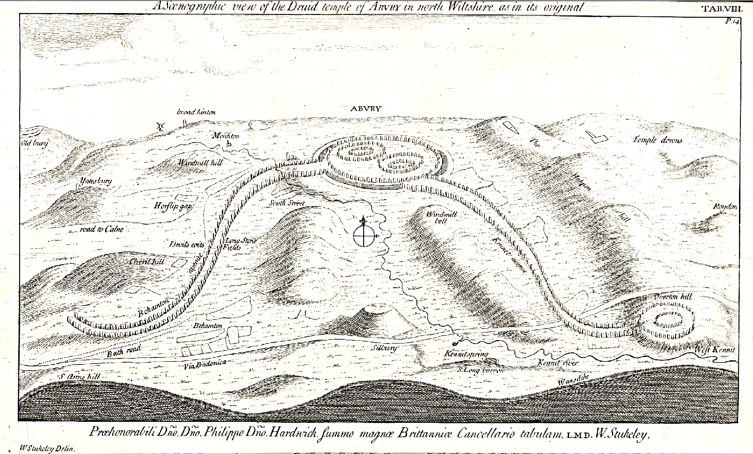

Fig. 2. "A Scenographic view of the Druid temple of Abury in north Wiltshire as in its original". After Stukeley 1743, Kennit [i.e., Kennet] Spring = Swallowhead Spring, lower right foreground.

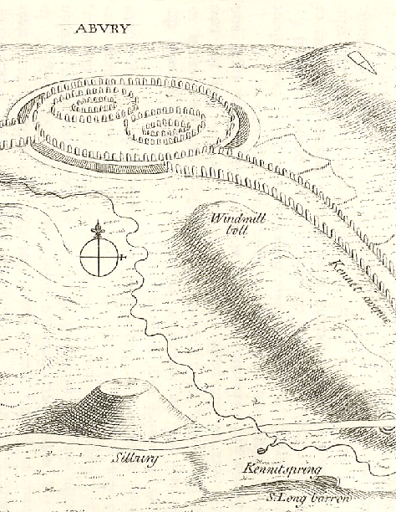

Fig. 3. Detail of "A Scenographic view of the Druid temple of Abury in north Wiltshire as in its original". After Stukeley 1743, Kennit [i.e., Kennet] Spring = Swallowhead Spring, lower right foreground.

**Cultural Affiliation:** Late Neolithic

**Medium:** Flint

**Dimensions:** 1-3 in

**Weight: various**

**Condition: original**

**Provenance:** Swallowhead Spring

**Discussion:** This collection of various flint tools used in butchering (knives, scrapers, burins, etc.) appears to have been made on the spot of a butchering camp in the area of Kennit [i.e., Kennet] Spring = Swallowhead Spring, perhaps concurrently with the building of Silsbury Hill, 2490 BCE-2340 BCE. The first reliable dating of Silsbury Hill was occasioned in 2002 when a 1776 excavation shaft near the top collapsed. This empoweredTheEnglish Heritage to excavate two small trenches in which they discovered an antler fragment that produced the first reliable radiocarbon date for the site of 2490 BCE-2340 BCE, the Late Neolithic (Field 2003).

**References:**

Field, David. 2003. ["Great sites: Silbury Hill"](http://www.britarch.ac.uk/ba/ba70/feat2.shtml). British Archaeology. York, England: Council for British Archaeology (70).

Stukeley, William. 1743. “A Scenographic view of the Druid temple of Abury in north Wiltshire as in its original,” *Abury, a temple of the British druids, and some others described*. London: Printed for the author; And sold by W. Innys, R. Manby, B. Dod, J. Brindley, and the Booksellers in London.

